Liam Fruzyna
COSC 4610
Assignment 1

#1 Compute standard deviation of each attribute. Compute boxplots for each attribute and interpret the results. Which attributes have the most variation. Are there any outliers in any of the attributes?

Sepal Length (cm) 0.825301
Sepal Width (cm) 0.432147
Petal Length (cm) 1.758529
Petal Width (cm) 0.760613
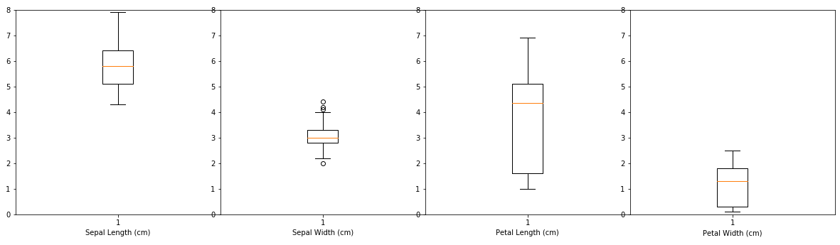
Petal length has the most variation as seen by having the tallest box. Only sepal width has outliers, 1 below and 3 above.

#2 Compute histogram for each attribute. Based on histogram and boxplot of each attribute, which distributions look similar to a normal bell curve, which ones look different?
(Sepal Length, Sepal Width / Petal Length, Petal Width)
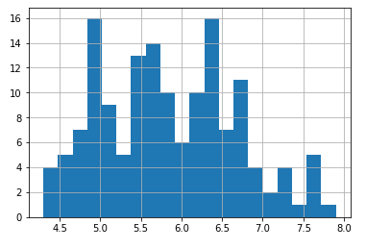
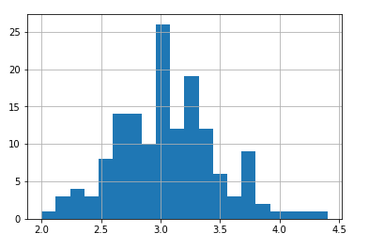
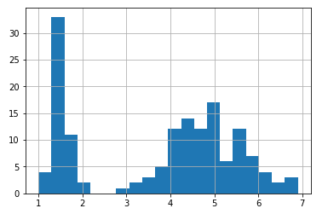
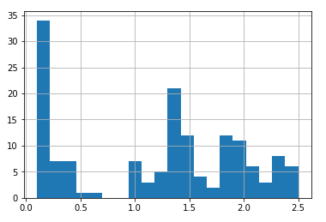

Sepal width is the only histogram that appears normal, sepal length appears to be tri-modal while petal length is bi-modal and petal width is very inconsistent

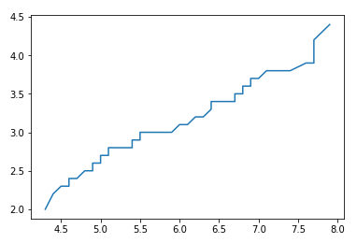
#3 Compute QQ plot between Sepal.Length and Sepal.Width and interpret the results with comparison to boxplots and histogram of these attributes.

The QQ plot appears to imply it being fairly normal.

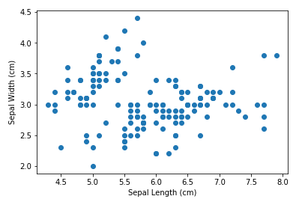
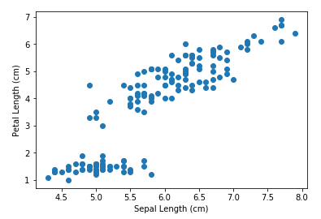
#4 Compute scatterplots between Sepal.Length and Sepal.Width, and Sepal.Length and Petal.Length. Interpret the results. Is there any correlation? Is it positive or negative?

There does not appear to be a correlation for sepal length and sepal width, however, there does appear to be a positive correlation for sepal length and petal length

